- ReactJS-HOL

App.js

import React from 'react';

function App() {
return (
<div>
<h1>Welcome to the first session of React</h1>
</div>
);
}

export default App;

OUTPUT
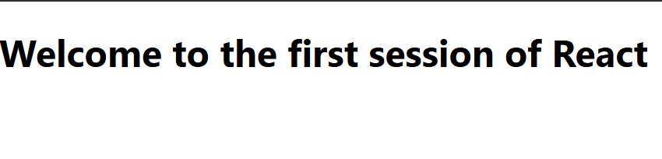

2.ReactJS-HOL
About.js
import React from 'react';

function About() {
return (
<div>
<h2>Welcome to the About page of the Student Management Portal</h2>
</div>
);
}

export default About;

Contact.js
import React from 'react';

function Contact() {
return (
<div>
<h2>Welcome to the Contact page of the Student Management Portal</h2>
</div>
);
}

export default Contact;

Home.js
import React from 'react';

function Home() {
return (
<div>
<h2>Welcome to the Home page of Student Management Portal</h2>
</div>
);
}

export default Home;

App.js
import React from 'react';
import Home from './Components/Home';
import About from './About';
import Contact from './Contact';

function App() {
return (
<div>
<Home />
<About />
<Contact />
</div>
);
}

export default App;

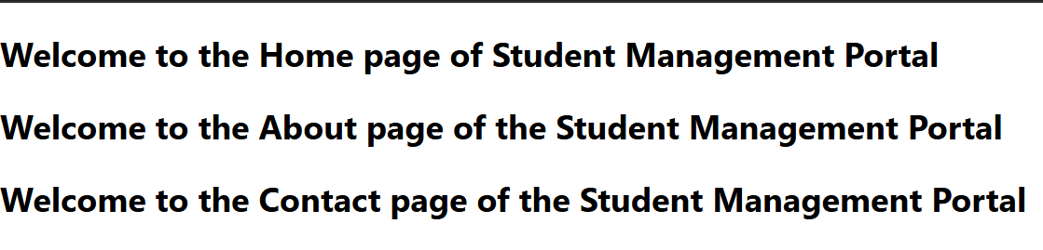

3.ReactJS-HOL

ReactJS-HOL

Mystyle.css

.Name{
font-weight:300;
color:blue;
}
.School
{
color:crimson;
}
.Total
{
color:darkmagenta;

}
.formatstyle
{
text-align:center;
font-size:large;
}
.Score
{
color:forestgreen;
}

CalculateScore.js
import './Stylesheets/mystyle.css';

const percentToDecimal = (decimal) => {
return decimal.toFixed(2) + '%';
};

const calcScore = (total, goal) => {
return percentToDecimal(total / goal);
};

export const CalculateScore = ({ Name, School, total, goal }) => {
return (
<div className="formatstyle">
<h1 style={{ color: 'brown' }}>Student Details:</h1>

<div className="Name">
<b><span>Name: </span></b>
<span>{Name}</span>
</div>

<div className="School">
<b><span>School: </span></b>
<span>{School}</span>
</div>

<div className="Total">
<b><span>Total: </span></b>
<span>{total}</span>
<span> Marks</span>
</div>

<div className="Score">
<b>Score: </b>
<span>{calcScore(total, goal)}</span>
</div>
</div>
);
};

App.js
import { CalculateScore } from './Components/CalculateScore';
function App()
{
return (
<div>
<CalculateScore Name={"Steeve"}
School={"DNV Public School"}
total={284}
goal={3}
/>
</div>
)
}
export default App;

OUTPUT
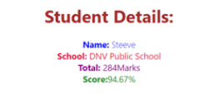

- ReactJS-HOL

Posts.js
class Post {
constructor(userId, id, title, body) {
this.userId = userId;
this.id = id;
this.title = title;
this.body = body;
}
}

export default Post;

Posts.js

import React, { Component } from 'react';
import Post from './Post';

class Posts extends Component {
constructor(props) {
super(props);
this.state = {
posts: [],
error: null
};
}

// Step 6: Load posts using fetch
loadPosts = () => {
fetch('https://jsonplaceholder.typicode.com/posts')
.then(response => {
if (!response.ok) {
throw new Error('Network response was not ok');
}
return response.json();
})
.then(data => {
const posts = data.map(post => new Post(post.userId, post.id, post.title, post.body));
this.setState({ posts });
})
.catch(error => {
this.setState({ error });
});
};

// Step 7: Call loadPosts() after mount
componentDidMount() {
this.loadPosts();
}

// Step 9: Catch and alert any rendering errors
componentDidCatch(error, info) {
alert('An error occurred: ' + error.toString());
}

// Step 8: Render posts
render() {
const { posts, error } = this.state;

if (error) {
return <h2>Error loading posts!</h2>;
}

return (
<div>
<h1>Blog Posts</h1>
{posts.map(post => (
<div key={post.id} style={{ marginBottom: '20px' }}>
<h3>{post.title}</h3>
<p>{post.body}</p>
</div>
))}
</div>
);
}
}

export default Posts;

App.js
import React from 'react';
import './App.css';
import Posts from './Posts';

function App() {
return (
<div className="App">
<Posts />
</div>
);
}

export default App;

OUTPUT
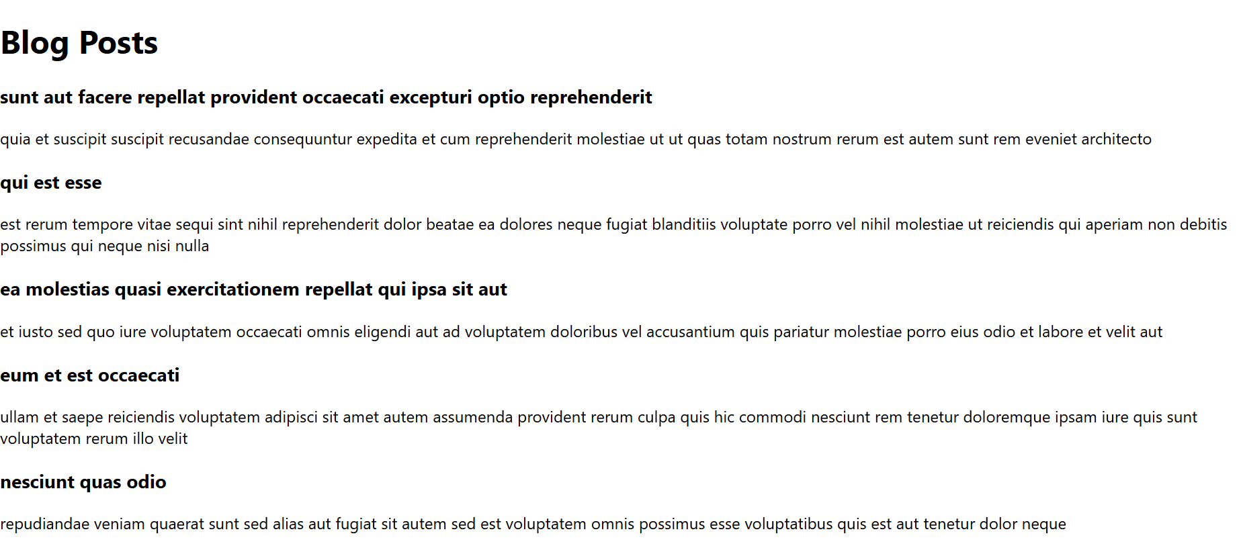

- ReactJS-HOL

CohortDetails.js

import React from 'react';
import styles from './CohortDetails.module.css';

function CohortDetails(props) {
const { cohort } = props;

const headingStyle = {
color: cohort.currentStatus.toLowerCase() === 'ongoing' ? 'green' : 'blue'
};

return (
<div className={styles.box}>
<h3 style={headingStyle}>
{cohort.cohortCode} -
<span> {cohort.technology}</span>
</h3>
<dl>
<dt>Started On</dt>
<dd>{cohort.startDate}</dd>
<dt>Current Status</dt>
<dd>{cohort.currentStatus}</dd>
<dt>Coach</dt>
<dd>{cohort.coachName}</dd>
<dt>Trainer</dt>
<dd>{cohort.trainerName}</dd>
</dl>
</div>
);
}

export default CohortDetails;

CohortDetails.module.css
.box {
width: 300px;
display: inline-block;
margin: 10px;
padding: 10px 20px;
border: 1px solid black;
border-radius: 10px;
}

dt {
font-weight: 500;
}
App.js
import React from 'react';
import CohortDetails from './Components/CohortDetails';

function App() {
const cohorts = [
{
cohortCode: "FSW2025",
technology: "Full Stack Web",
startDate: "2025-06-01",
currentStatus: "ongoing",
coachName: "Rahul Verma",
trainerName: "Meena Iyer"
},
{
cohortCode: "JAV2025",
technology: "Java",
startDate: "2025-04-15",
currentStatus: "completed",
coachName: "Sahil Anand",
trainerName: "Rohit Das"
}
];

return (
<div>
<h2>My Academy Cohort Dashboard</h2>
{cohorts.map((cohort, index) => (
<CohortDetails key={index} cohort={cohort} />
))}
</div>
);
}

export default App;
